Howdy so as part of my trying to get more slaves published. I thought I would try to help out aspiring creators by putting out some tutorials for using the SDK. Basically these lessons are designed to provide you with the code and knowledge to be able to create a girl with minimal head beating against walls.

Lesson 1: Getting Started

I usually skip this part too... so ignore it if you feel like it.

Part A: Flash

So if your like me and know nothing about flash, and were a c++ bottle baby, I highly recommend giving these video tutorials a look. If you know absolutely nothing about programing you might have an issue but if your familiar with any object oriented programing and can copy and paste code you should be fine. The following videos are a great flash course and represent all I know about flash as well.

http://www.adobe.com/devnet/actionscript/articles/actionscript_1-on-1.html

Part B: Gathering Images

All I can do is suggest some places I use, and I'm sure there are better sites that I don't know.

http://rule34.paheal.net/

http://danbooru.donmai.us/
http://gelbooru.com/

http://g.e-hentai.org/

http://www.doujin-moe.us/

After you have your images, I recommend sorting them, by how you will use them. Some way that makes sense to you is whats important here, its supposed to minimize your seek time later on.
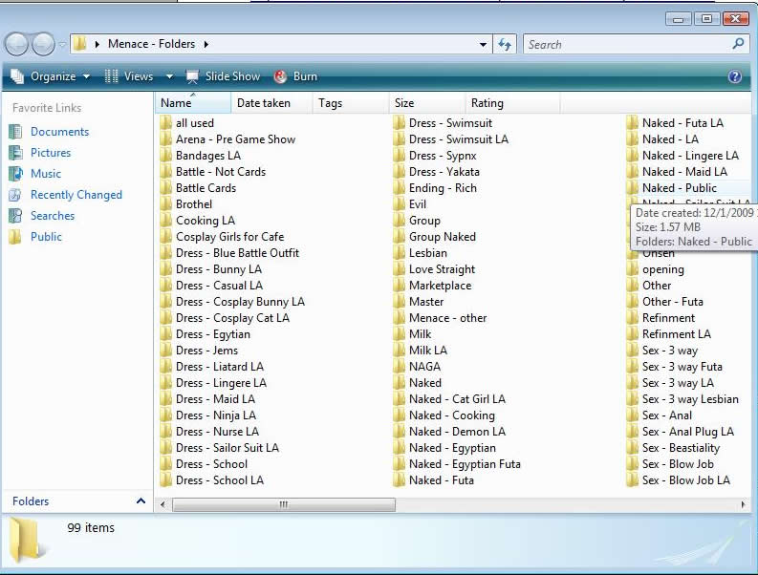

Part C: Back Ups

I highly recommend creating a copy of the SDK and Slave Master marked work or something just in case you screw something up. Create copies of Akane (Slave-Girl.as and Slave-Girl.fla) and rename them to your girl.

Part D: The Cheat Sheet

This is completely optional but the SDK is quite large and there are certain things that I find I need to check often and don't want to find over and over again.

First off is ON, OFF, ON, ON, OFF OFF will explain in next lesson

Second is 7x5 the shift on the stage and 448x336 the stage size, 231x168 half way points, I'm bad about memorizing numbers if you can remember more power to you otherwise write it in the cheat sheet.

Also the positions for the assistant box is

The third item is : 6 x 341.5 location and 154 x 153 size

_root.Points(0, 0, 0, 0, 0, 0, 0, 0, 0, 0, 0, 0, 0, 0, 0, 0, 0, 0, 0, 0);
1Charisma, 2Sensibility, 3Refinement, 4Intelligence, 5Morality, 6Constitution, 7Cooking, 8Cleaning, 9Conversation, 10BlowJob, 11Fuck, 12Temperament, 13Nymphomania, 14Obedience, 15Libido, 16Reputation, 17Fatigue, 18Joy, 19Love, 20Special

Cmacleod uses the following and replaces each word with numbers.

_root.Points(Charisma, Sensibility, Refinement, Intelligence, Morality, Constitution, Cooking, Cleaning, Conversation, BlowJob, Fuck, Temperament, Nymphomania, Obedience, Lust, Reputation, Fatigue, Joy, Love, Special);

These are the stats and once you have counted it out a few times to make a change on her Obedience stat you will find out why this is on the cheat sheet, both versions are included on the sheet.

The last item in our cheat sheet is variables, its a good idea to put them at the top of the .as file. But I also recommend putting into your cheat sheet that way you wont have to scroll to the top of the document to check which variable is which.

Something like

Custom Flags:

Bit Flags:

These will be explained later on in another lesson

Part E: Stripping out Akane

Don't reinvent the wheel, is one of the best basic practices of Programing and you have Akane, might as well make use of her. “//” is for commenting 1 line and “/* and */” for blocks. I don't recommend deleting code just commenting it out for now. I also recommend commenting on each function something simple like “// unmodified” that way you know later on whether you have already worked on it or not. Set all difficulty to 0 for debugging. Give yourself a little extra cash. Set obedience starting high. Set all custom flags to 0, will harp on this later on.

Turn Debugging on in start up

_root.SlaveDebugging = true;

How to use debugging click on the “G” in gold when running slave maker.

I'm going to included my stripped version with these lessons, but I recommend stripping your own, after all if you don't like stripping a girl your in the wrong business, will also put in my cheat sheet and a complete copy of the SDK in one file to promote searching.

Well I think that's enough prep. Next Time will do dresses, just because it will be the first thing everyone rushes too.

